The PaCE (Postsecondary and Career Expectations) framework provides guidance to parents, teachers, school administrators, community based organizations, and students on what experiences students should have and what information students should know during their progression from middle grades through high school. The framework is organized around the principle that practical and financial preparation for college and career can and should be done together.
PaCE is intended to be used as a framework for communities to organize their activities around student college and career readiness and as a guide for state agencies to target specific supports where needed. The specific milestones that are provided in PaCE are not intended to create an additional burden for students, educators, and families; rather, the expectations outlined in PaCE can and should be blended into existing coursework, counseling activities, after school programs, and family activities as students prepare for college and career.
The framework should be easy to use and ideally will be in an online, interactive format that is accessible for practitioners, students, and families, and should be linked through existing state tools, such as the ISAC Student Portal, Career Information System, or through online career exploration providers, such as Career Cruising or Naviance. Where applicable, links of resources should be provided through the framework.
Example:
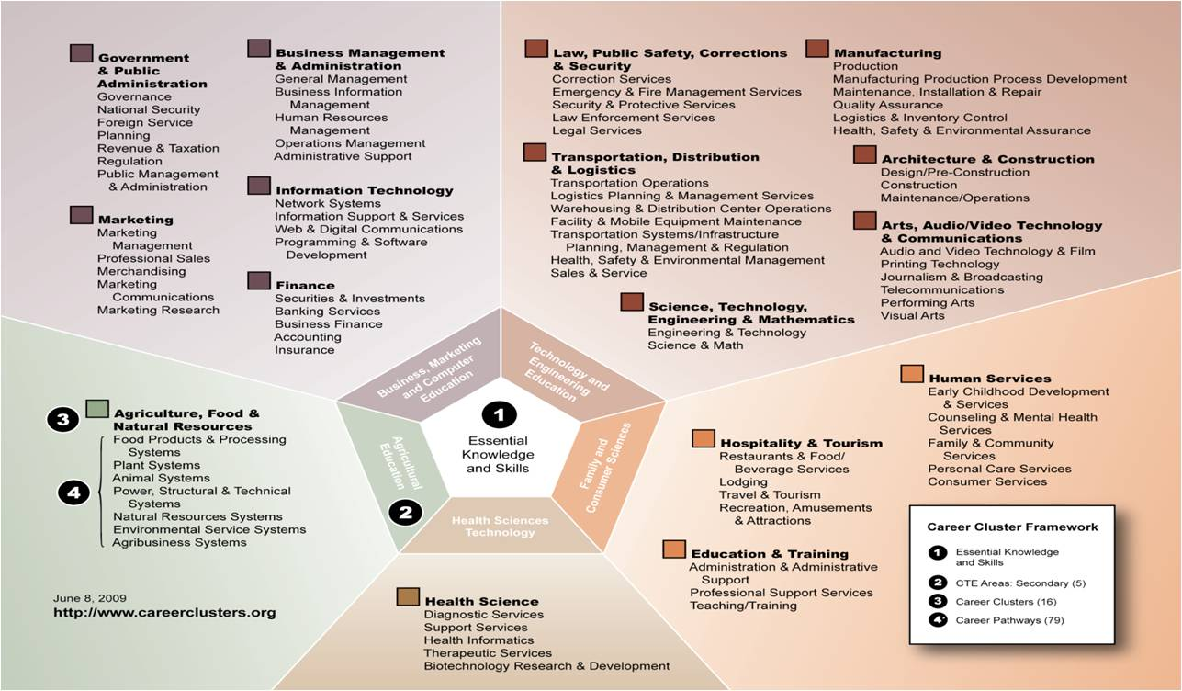
By the end of 8th grade, a student should know the concept of career clusters for further exploration. The rationale for understanding the career clusters framework is that it offers an organizing structure for students to explore potential careers of interest to them and provides knowledge and skill standards for educators and practitioners.
The career clusters and additional resources, such as a career clusters activity, can be linked in the PaCE framework. As communities work to transition their students from middle school to high school, the following activities can be considered:
- The career clusters can be presented in a school-based workshop for outgoing 8th graders as they prepare for high school registration.
- The career clusters can be shared with families during an orientation night to high school, where families can be encouraged to explore the career clusters activity together as they begin preparing for high school registration.
- 8th grade instructors can commit to including the framework in particular lessons, using the career clusters activity to structure classwork.
- Community-based organizations that interact with students and families and schools can work together to use the career clusters to structure activities, such as career fairs, mentorship programs, and content specific programs.
Connections across the framework:
The PaCE framework can be a powerful instrument for communities to come together around specific expectations, milestones, and activities that drive student college and career preparation, readiness, and success. However, these expectations should not be individually considered in a vacuum. In the example above, career clusters are introduced in the 8th grade as a way for students to begin exploring careers of interest to them. Once students have been introduced to the career clusters, the clusters can be used as an organizing tool for discussing postsecondary plans and understanding financial obligations and returns-on-investment of specific postsecondary options, participating in community service, extracurricular, and work-based learning activities, as well as making important postsecondary and career decisions.
An organizing framework:
Communities can be incentivized to use this tool as part of a broader program to drive student college and career readiness. Using existing organizing networks in Illinois, communities can be incentivized to use the PaCE framework as a coordinating structure around their education to employment initiatives. Successful implementation of PaCE will include professional development and a statewide awareness and communications campaign, the goal of which would be to make sure that all school districts and ideally non-profit partners, students, and families understand that they need to support students to “keep PaCE” and build out the systems that make that happen.

www.studentportal.isac.org
https://ilcis.intocareers.org/materials/portal/home2.html
Example: http://www.educationplanner.org/students/career-planning/find-careers/career-clusters.shtml

